[CEN 323 ] Computer Organization & Assembly Language
Lab 7 Journal

Name :Bilal Aamir
Enrollment Number:01-135232-016

Lab Deliverables (submission guideline)

Create a folder named after your enrollment number and add the following files:
  - Create a folder named YourRollNumber_Lab7 containing:
- .asm files of the three practice tasks.
- Add full screen screenshots of the code and output in this word file.
  - Zip the Folder and upload to LMS.

Lab Task

Task 1:
Code (TEXT):
include emu8086.inc
.data
OuterBack db ?
InnerBack db 9
num db ?
Spaces db 1
.code
main:
mov ax,@data
mov ds,ax

mov cx,5

OuterLoop:
mov OuterBack,cl
mov cl,Spaces
INC Spaces
SpacesLoop:

PutC 32

Loop SpacesLoop
mov cl,OuterBack

mov OuterBack,cl
mov num,cl
mov cl,InnerBack

InnerLoop:

mov dl,num
add dl,48
putc dl

loop InnerLoop
sub InnerBack,2

xor cx,cx
mov cl,OuterBack
PrintN ""
loop OuterLoop

mov ah,4Ch
int 21h
end main

Screenshot (CODE):
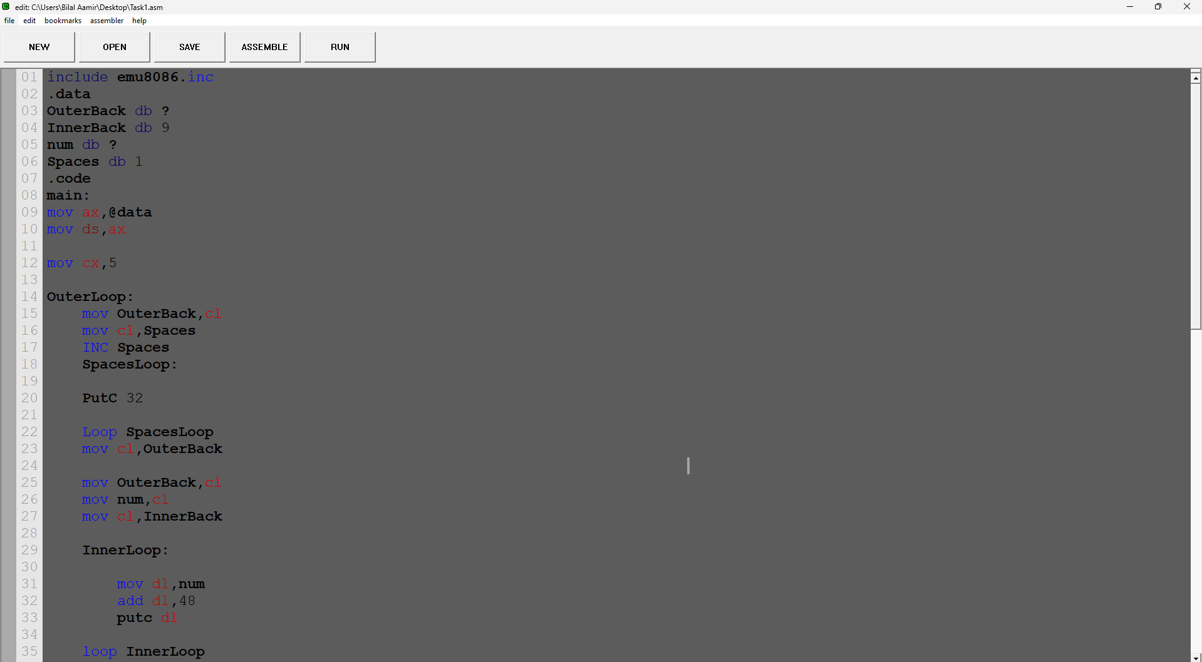

Screenshot (OUTPUT):
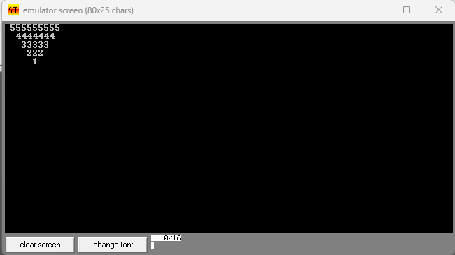

Task 2:
Code (TEXT):

include emu8086.inc
.data
OuterBack db ?
InnerBack1 db ?
InnerBack2 db ?
SpacesLoop db 3
Minus db 1
comp db 1
start db 1
startPrint db ?
ToPrint db 0

.code
main:
mov ax,@data
mov ds,ax
mov cx,4
Outer:
mov OuterBack, cl

mov cl, SpacesLoop
cmp SpacesLoop, 0
je SkipSpaces

Spaces:
putc 32
loop Spaces

SkipSpaces:
mov cl, start
mov startPrint, cl

InnerLoop1:
cmp startPrint, 0
jz Cont
mov dl, startPrint
add dl, 48
putc dl
dec startPrint
loop InnerLoop1

Cont:

mov cl, ToPrint
mov startPrint, 2

InnerLoop2:
cmp cl, 0
je Cont2
mov dl, startPrint
add dl, 48
putc dl
inc startPrint
loop InnerLoop2

Cont2:
mov cl, OuterBack
printn ""
inc start
dec SpacesLoop
inc ToPrint
loop Outer

mov ah,4Ch
int 21h
end main

Screenshot (CODE):
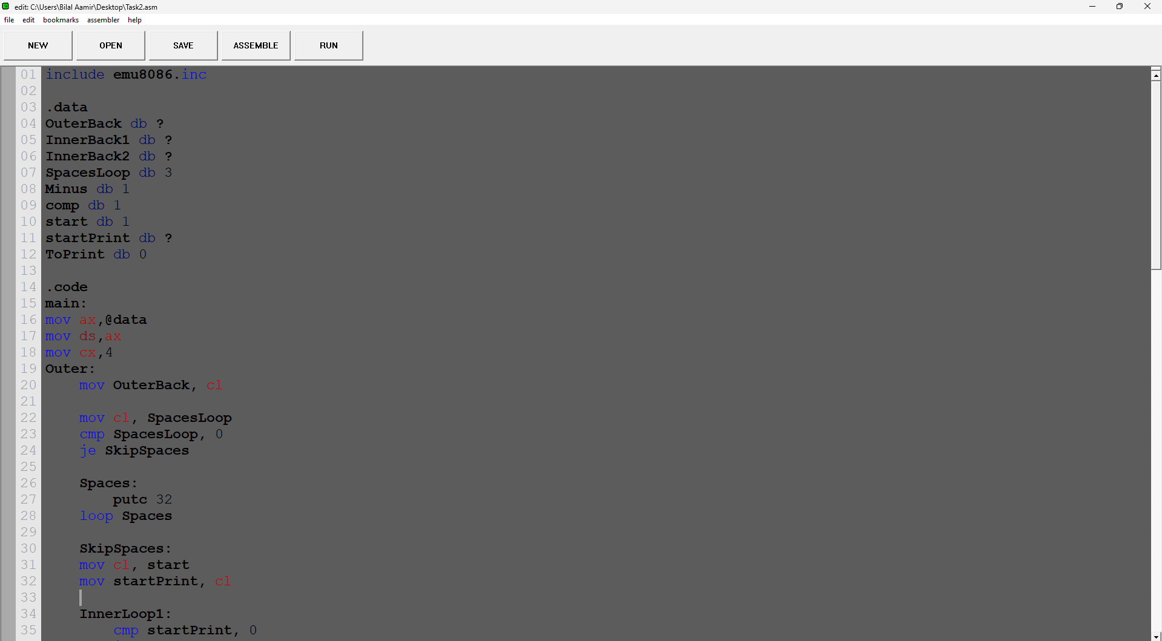

Screenshot (OUTPUT):
